Practical - 6
Practical Title: Rendering External JSON Data using Fetch API, Search and Filter
Problem DefinitionDisplay event lists, student profiles, notices, or FAQs from external JSON files using Fetch API. Implement dynamic rendering, search, filter, sorting, and pagination.
1. How is JSON fetched, parsed, and rendered?
Answer: I use the Fetch API to request the JSON file, for example fetch("events.json"). The server's reply is a Response object, so I call response.json() on it. This turns the raw JSON text into a normal JavaScript array of objects. I then loop over the array with map() and build an HTML card for each record. Finally I put all the cards into the page by setting innerHTML of a container element. Because the data comes from a separate file, I can change the records without touching the HTML.
2. Which array methods are used for search, filter, sort, and pagination?
- Answer: Search: filter() together with includes(). The text is converted with toLowerCase() so the search is not case-sensitive.
- Filter: filter() again, to keep only the records that match the chosen category or status.
- Sort: sort() with a compare function, for example by date, or by name using localeCompare().
- Pagination: slice(start, end), where start = (currentPage - 1) × itemsPerPage. The number of pages is Math.ceil(totalItems / itemsPerPage).
3. How are loading and error states handled?
Answer: Before the fetch starts, I show a "Loading..." message. After the data arrives, I hide it and show the list. I wrap the fetch in try...catch (or use .catch()). I also check response.ok, because a wrong file name gives a 404 that does not throw an error by itself. If something fails, the page shows a friendly message like "Unable to load data. Please try again." If the search or filter finds nothing, the page shows "No records found" instead of staying blank.

4. How is modularity maintained in JavaScript files?
Answer: I split the code into separate files by job:
- fetchData.js fetches and returns the data.
- render.js builds the HTML.
- filters.js handles search, filter, and sort.
- pagination.js handles page logic.
- main.js connects everything and handles event .

B. Implementation / Output / Result
[
{ "id": 1, "title": "Hackathon", "category": "Tech", "date": "2026-10-20" },
{ "id": 2, "title": "Dance Night", "category": "Cultural", "date": "2026-10-25" },
{ "id": 3, "title": "Cricket Cup", "category": "Sports", "date": "2026-11-02" }
]

C. Evidence of Work (Screenshots)

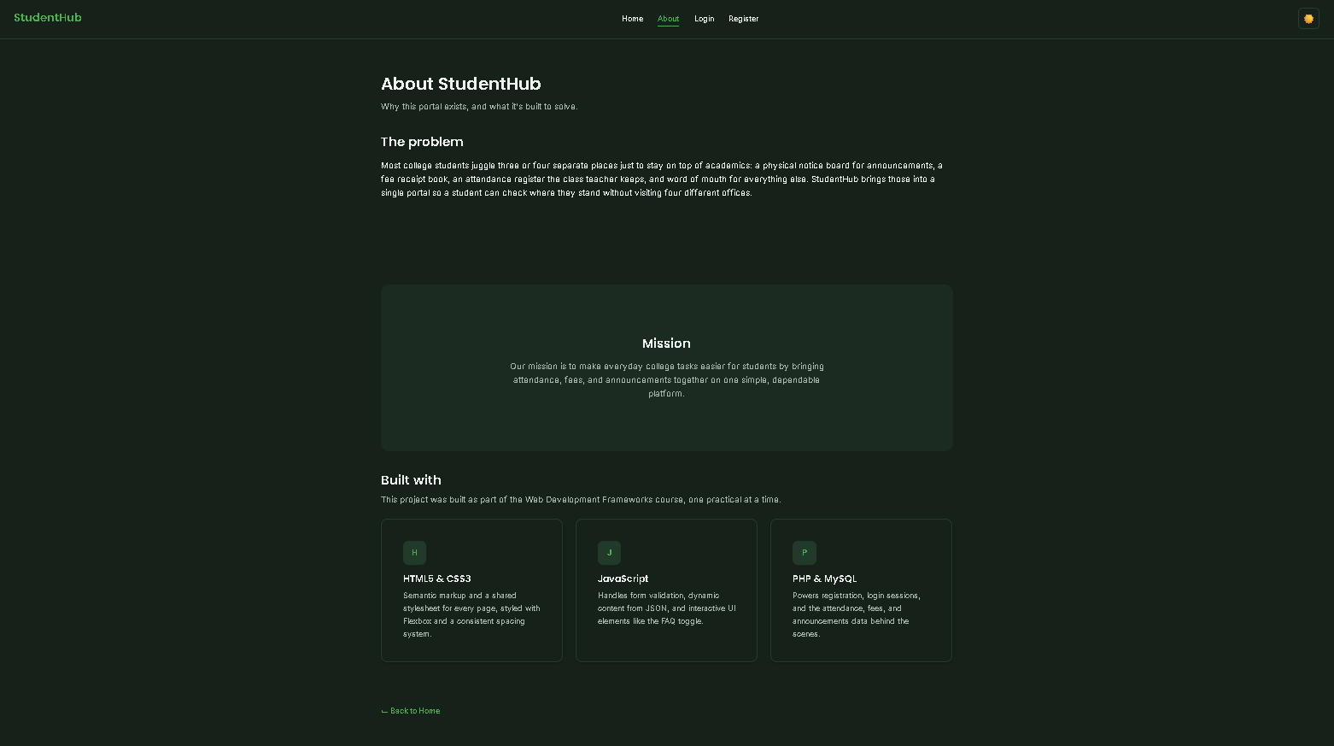

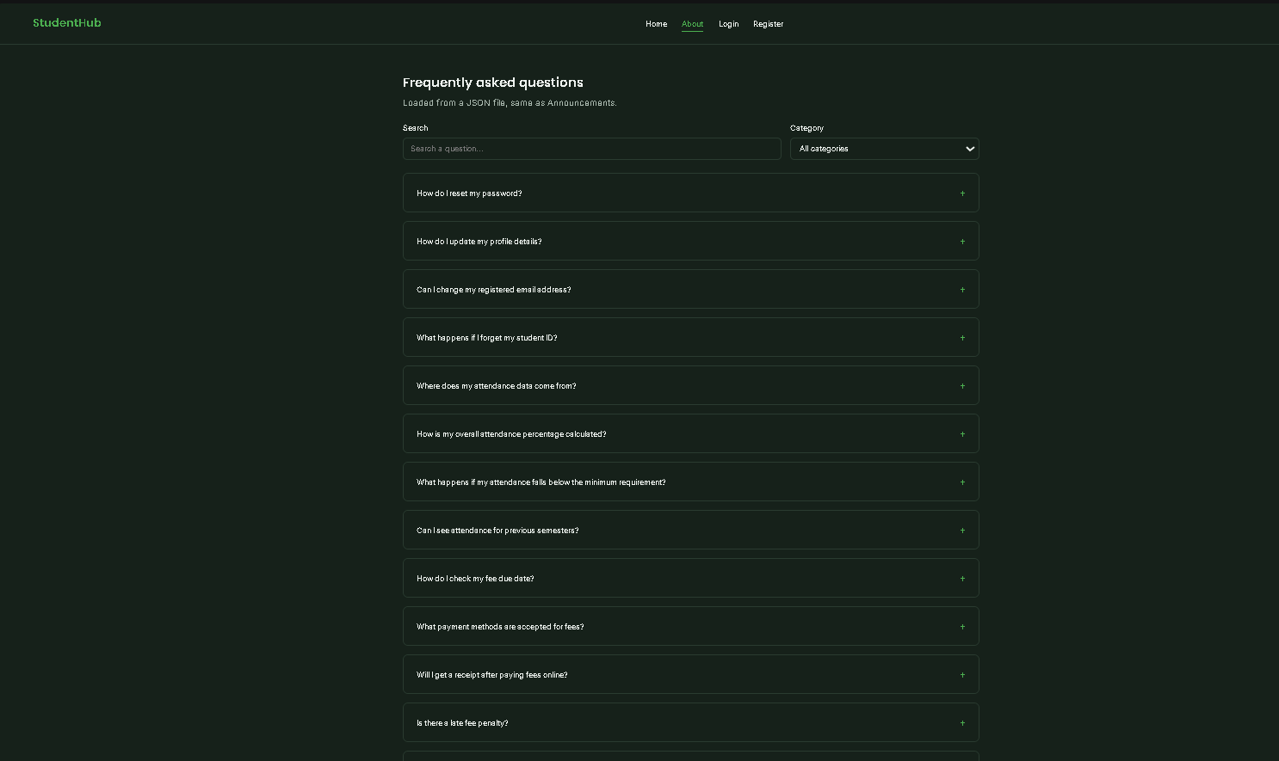

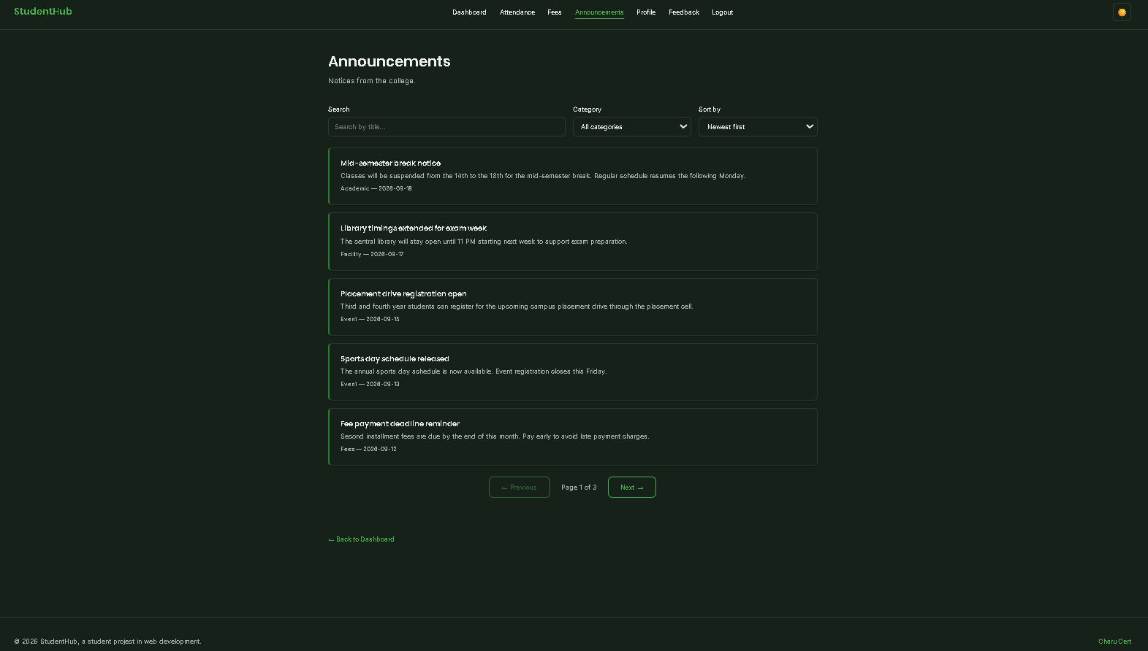

D. GitHub Repository Link :

https://github.com/kvvaghasiya49/Web_Development.git

E. Challenges Faced:

- Fetch gave a CORS or blocked-file error when I opened the HTML file directly from my computer. I fixed it by running the project through a local server (VS Code Live Server or XAMPP).
- Wrong JSON file path gave a 404 error. I fixed it by checking the folder structure and using the correct relative path.
- JSON syntax mistakes, such as a trailing comma or single quotes, broke parsing. I fixed them with a JSON validator.
- Search and filter did not work together. One was resetting the other. I solved it by applying all conditions to the original array, one after another.

F. Learning Outcomes:

- I can fetch external JSON data and render it dynamically on a web page.
- I understand how map, filter, sort, and slice work, and I can use them for search, filter, sort, and pagination.
- I can handle loading, empty, and error states to give a good user experience.
- I can organise JavaScript into reusable modules.

G. Faculty Remarks:

